Top 10 Popular IoT Development Tools

May 14, 2019

[2](https://blog.eduonix.com/internet-of-things/top-10-popular-iot-development-tools/#comments)

6200

[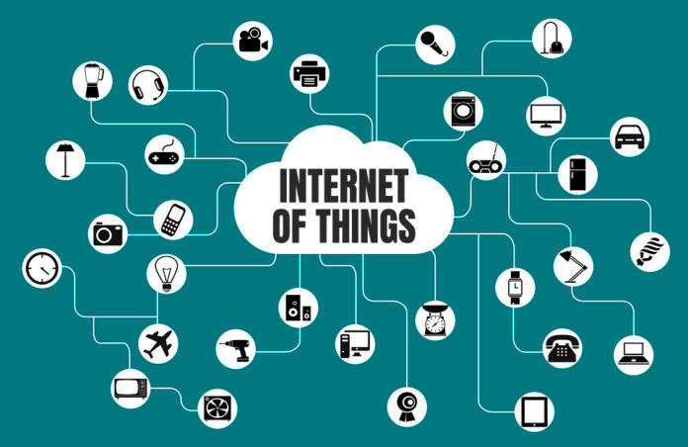](https://blog.eduonix.com/wp-content/uploads/2019/05/Internet-of-Things.jpg)

You will agree with the fact that it is indeed a herculean task to build a complex application, more so when it concerns the use of IoT hardware and software. However, you have ample opportunities that come in the form of development kits and tools that will help you come up with the best practices to build an IoT solution.

Certainly, IoT is the latest buzzword that is doing rounds in the internet-driven space. Going by the numbers, in 2015, there were 15.41 billion IoT connected devices which have now grown to 26.66 billion and it is expected to surpass 75 billion devices by 2025. Majority of these devices are used in the healthcare industry or [business/corporates](https://codecondo.com/how-the-iot-is-transforming-corporate-events/) and manufacturing industry.

Moreover, to fuel this progressive trend, a host of Internet of Things solution providers are busy creating software and hardware designs that will help developers come up with novel IoT applications and devices.

To know in detail about the IoT concept you can read[**IoT- No Need to Wait When Devices Communicate**](https://blog.eduonix.com/internet-of-things/iot-no-need-wait-devices-communicate/)**.**

**Read More:** [**Jobs In Demand For 2020 & Beyond: 15 Careers You Can’t Ignore!!**](https://blog.eduonix.com/featured/jobs-in-demand-for-2020-15-careers-cant-ignore/)

Here are the top-class IoT development tools that can be employed by both developers and for all those who wish to pursue IoT as a DIY hobby.

**1. [Tessel 2](https://tessel.io/" \t "_blank)**

This is a hardware provider that can be used to build basic IoT solutions and prototypes. Tessel 2 lends a helping hand through its numerous sensors and modules. This is a board which can hold up to a dozen modules including the RFID, camera, GPS and the accelerometer.

All those Java developers who are proficient with Node.JS can use this device as Tessel can be programmed using Node.JS. This way, Tessel can be used to churn out a host of server and hardware firmware IoT solutions. Tagged as a robust IoT platform, you can leverage all the libraries of Node.JS to unveil a host of devices; within a matter of minutes.

It comes with two processors, the Tessel hardware makes use of a 580MHz Mediatek MT7620n and 48MHz Atmel SAMD21 coprocessor. While one can be used to run your firmware applications at a rapid speed, the other finds its use in exercising better input/output control and the efficient management of power.

**2.**[**Eclipse IoT**](https://iot.eclipse.org/)

If you as an IoT developer are ordained to build IoT devices, Cloud platforms and Gateways, then Eclipse IoT can be your top bet. Recognized as a collaboration of various companies and individuals who are striving towards the development and establishment of IoT open technologies, Eclipse IoT can make all your IoT dreams come true.  
Allowing you to develop, promote and adopt open source IoT technologies, Eclipse IoT is an instrument that can help you gain technical expertise. Simplylook into the vast assembly of services and projects delivered by the Eclipse team and you are all covered.

**3.**[**Arduino**](https://www.arduino.cc/)

If you are looking to build a computer that can sense and exercise a better control over the physical world when compared to your normal stand-alone computer, then Arduino can be your intelligent choice. Offering a perfect blend of IoT hardware and software, Arduino is an open-source prototyping and simple-to-use IoT platform. Arduino operates through a set of hardware specifications that can be applied to interactive electronics. The software of Arduino comes in the form of the Arduino programming language and Integrated Development Environment (IDE).

**4. [PlatformIO](http://platformio.org/" \t "_blank)**

Next in the list of top IoT development tools and platforms is PlatformIO which is a cross-platform IoT development environment. This platform comes with a build system, supported by a library manager and IDE. You have a choice to port the IDE on top of the Atom editor or you can go ahead and install it as a plug-in.

The best part of PlatformIO is that it is compatible with more than 200 boards. Coming with a wonderful debugging integration, PlatformIO is conspicuous of a serial port monitor. All those who are employing PlatformIO unanimously express one feeling and that is – “PlatformIO hastens up the development process of an IoT application, allowing us to deliver IoT solutions in record time”.

**5.**[**IBM Watson**](https://www.ibm.com/watson)

Last in the list of top IoT development tools, but definitely not the least is IBM Watson, an API that allows you to attach a host of cognitive computing features to your IoT applications. This is an innovative tool that can also be used to predict the future.

Simplifying the tasks of IoT developers, IBM Watson through its numerous services helps to unveil chatbots which can understand the natural language. These chatbots can then be deployed on to messaging platforms and websites which can be viewed on various devices. It is through IBM Watson that IoT developers can successfully and swiftly build cognitive search and content analytics engines.

**6. [Raspbian](https://www.raspberrypi.org/downloads/raspbian/" \t "_blank)**

This IoT IDE is created for Raspberry Pi board by IoT tech enthusiasts. With over 35,000 packages and numerous examples along rapid installation with the use of pre-compiled software makes it an essential IoT development tool. Often, it is regarded as the best tool for Raspberry Pi for IoT app development. Another best part about this tool is that it is under constant development and has widened the reach for computing so that users can gain maximum benefits.

To learn about Raspberry Pi for home automation you can explore the different sections of **“**[**From 0 to 1: Raspberry Pi and the Internet of Things**](https://www.eduonix.com/from-0-to-1-raspberry-pi-and-the-internet-of-things/?coupon_code=edublog10&utm_source=Blog&utm_medium=Eduonix)**”** online tutorial. It teaches you about the basics of IoT, Pis anatomy, Coding with Python, Physical Computing with Raspberry Pi and so much more!

**7. [OpenSCADA](http://oscada.org/" \t "_blank)**

This tool is a part of the SCADA project by Eclipse IoT industry groups. It is independent to any platform and is known for its security and flexibility along with a modern design. OpenSCADA also supports editing and debugging and comes with front-end applications, back-end applications, libraries, configuration tools and interface applications. Its different tools can be combined with the development of advanced IoT applications. Unlike other IDEs, OpenSCADA supports various programming languages and consists of sub-projects like Atlantis, Utgard, Orilla and others.

**8.**[**Node-RED**](https://nodered.org/)

Node-RED is a simple visual tool that is built on Node.js, a server-side JavaScript platform that is widely used in IoT projects. It is an open-source tool mainly used to connect devices, services and APIs together with an integrated browser-based flow editor. With over 60,000 modules, it was developed by IBM with the aim of providing a user-friendly interface for developers allowing them to connect devices very quickly and easily.

For learning Node.JS from the very beginning you can opt for **“[NodejS from Ground Up for Beginners](https://www.eduonix.com/nodejs-from-ground-up-for-beginners/?coupon_code=edublog10&utm_source=Blog&utm_medium=Eduonix" \t "_blank)”** online tutorial. It unfolds with the installation, NPM, serving files, real-time HTTP requests, Express, MongoDB and other core concepts.

**9. [Kinomo Create](https://www.indiegogo.com/projects/kinoma-create" \l "/" \t "_blank)**

It is a device that can connect two devices without extensive knowledge of JavaScript. Kinoma Create consists of everything which is required for developing small IoT applications like connecting light, temperature or movement sensors for a specific purpose with mobile notifications in case of any alterations. You can also find numerous tutorials on its practical applications at Kinoma’s website. It has been widely used for developing a synthesizer, a camera trap which takes a photo if an animal or any other objects disturbs the laser beam and an automatic alarm bell for alerting individuals in case of any situations.

**10.**[**Device Hive**](https://www.devicehive.com/)

Device Hive is a free open source machine to machine (M2M) communication framework which was launched in 2012. It is a Data Art’s AllJoyn based device and is considered one of the most preferred IoT app development platforms. It is generally a cloud-based API that you can control remotely without the need for network configuration. The same implies to the libraries, portals and management protocols. Mostly, it is used for security, automation, smart home tech and sensors. Additionally, it also has a dynamic community and myriads of online resources available to help you out.

***Here’s A Bonus One Just for You***

**11.**[**Home Assistant**](https://www.home-assistant.io/)

It is an open-source tool that is primarily aimed at home automation and functions with a Python-based coding system. The IoT system developed with this tool can be easily controlled with mobile or desktop browsers. Furthermore, its set up is easy and is trusted for operations, security and privacy. The software supports any systems which are running on Python 3 and all the systems get regular updates within 2 weeks. Despite the lack of cloud components, its ability to protect the data during this internet age gives it an edge over others

## 5 main principles that must be taken into account by IoT developers before creating an application

1. **Ensure the safe collection of data.** The collection of information through special equipment (sensors, etc.) is carried out outside of the usual data transmission networks. Therefore, when developing a custom Internet of Things application, it is very important to think of ways to protect the received information (in particular, the integrity and security of the initial settings in such devices, and mechanisms for the sensitive data encryption).
2. **Organize high-performance data streaming.** As a rule, data collection systems consist of hundreds, even thousands of electronic devices. Therefore, for the efficient streaming of such large volumes of information, it is necessary to think over independent mechanisms that are different from traditional packet transfers.
3. **Create an Internet of Things platform.** The IoT platform is a set of software tools that collectively help to systematize, store and process data received from electronic devices.
4. **Develop an Internet of Things solution in the cloud.**In order to guarantee the fast delivery of processed data to a user device, and also to organize centralized storage, cloud solutions are usually used. Such systems can ensure the efficient operation of the Internet of Things application with minimal operating costs and requirements for carrier networks.
5. **Provide for effective data management.** In-memory analysis and data processing systems are most often used. Such solutions ensure the rapid delivery of the processed results to the end user, even in the event of the data collection devices’ failure.

## Developing an Internet of Things-based application: 4 consecutive stages

**Choose the hardware.**Devices designed to collect information are characterized by:

* Extremely low levels of power consumption;
* Wireless transmitters to support communication;
* Primitive embedded OS.

In most cases, the purchase of such equipment is not included in the list of tasks for the developer, since all the popular platforms for development of Internet of Things applications are integrated with a number of physical and virtual tools for the collection of necessary data.

**Select centralized data storage.** A cloud or similar centralized repository is ideal for accumulation, systematization and further analysis of collected data. In particular, cloud solutions are ideal from the point of view of providing efficient data transmission over low-speed networks.

**Develop the server-side of data-handling algorithms.** To sort and analyze the collected information, IoT application development platforms offer extensive functionality that allow for the creation of a high-performance, intelligent and scalable backend. Our [article about IoT Architecture](https://applikeysolutions.com/blog/iot-architecture-technology-stack-and-protocols) might help you.

**Create a front-end.** Almost all modern platforms for the development of Internet of Things applications allow for the creation of full-featured, user-friendly front-end application interfaces with advanced search functions and intuitive structures.

## Development from scratch: choosing the best options to develop IoT apps

To help develop IoT apps from scratch, many special platforms have been created over the last few years. Below, we have listed the most popular, which will allow you to create your own Internet of Things application as quickly as possible.



### The top 5 tools to build an Internet of Things application

* **Azure IoT Suite.** Azure IoT Suite is an incredibly popular software package from Microsoft, specifically created for the simple integration of information collection devices into a consolidated system for transferring, storing, analyzing and processing data. Thanks to cloud architecture, the Azure IoT Suite provides access to a reliable and scalable storage bank of large volumes of information. Microsoft Azure Cloud is also supplemented with an extensive list of advanced services, including Azure IoT Hub (for device-to-cloud and cloud-to-device messaging), Azure Stream Analytics (for data sorting), Azure Storage, Azure Cosmos DB (for secure metadata storage and management of assembler devices), and Azure Web Apps Microsoft Power BI (for the creation of front-ends).
* **Amazon Web Services.** It's no news that one of the world's largest trading platforms has introduced special tracking chips that allow for monitoring the location of goods at any stage of their delivery. To provide efficient data exchange between chips and hardware such as PCs, Amazon Web Service was developed in 2006, which is a full-fledged infrastructure of agnostic platforms, including file hosting, cloud computing, virtual servers, and much more. The main advantages of this solution for the Internet of Things apps development include increased security (in compliance with DSS, FISMA, HIPAA and many other specifications), flexibility (thanks to the support of agnostic protocols) and adaptability (due to its cloud architecture).
* **IBM Watson.** The artificial intelligence based IBM Watson software implements support for a reliable relationship between information collection devices, servers and user parts of the developed applications. Creating such an application with the help of IBM Watson services is really simple. Thanks to the advanced functionality that allows for quick connection of gateways and data collection equipment, thoughtful storing and processing algorithms, real-time analysis instruments, and advanced security measures, this set of intuitive tools allows for the quick creation of enterprise level Internet of Things applications. IBM Watson services are available on the popular IBM Bluemix platform - cloud-based PaaS based on SoftLayer infrastructure, with support for Python, Java, Swift, Ruby, Node.js, PHP and other equally popular development languages and frameworks.
* **Oracle IoT.** Oracle IoT is one of the leading software solutions for the development of Internet of Things applications, built over one of the most flexible programming environments - Oracle. Based on cloud computing technologies, applications created with Oracle IoT have a whole host of advanced capabilities, including device virtualization, high-speed messaging, endpoint management, stream processing, data enrichment, event storage, REST API support, and enterprise connectivity. This is just a few of the Oracle IoT features and is by no means an extensive list. In 2017, this platform was complemented with new products: IoT Asset Monitoring Cloud, IoT Fleet Monitoring Cloud, IoT Production Monitoring Cloud, and IoT Connected Worker Cloud, designed to solve a number of business tasks and improve the process of converting data into the user-friendly form.
* **KAA IoT.** The open-source KAA IoT platform offers an incredibly rich toolkit for developing IoT applications, embodying best practices for software creation. KAA IoT has a lot of advanced features; among them, a well-thought-out functionality for the adjustment of mobile device compatibility, flexible management of an unlimited number of sensors for the collection of information through an SDK server, real-time sensor monitoring, cloud services, automation of software updates, automated user personal device settings distribution, etc. All these features, when combined, make KAA IoT one of the most advanced products for the development of this kind of software.

Read more: [Smart Home Apps: Development, Best Cases, Trends 2019](https://applikeysolutions.com/blog/smart-home-apps-development-best-cases-trends-2019)

### The 5 fastest-growing areas for Internet of Things applications

1. **Smart homes.** Automated house management systems are being actively promoted in highly developed countries. Software for water, electrical, gas and heating resource planning, security and remote control systems are all based on the Internet of Things concept, and will soon minimize the need for human oversight by becoming completely common attributes of everyday life.

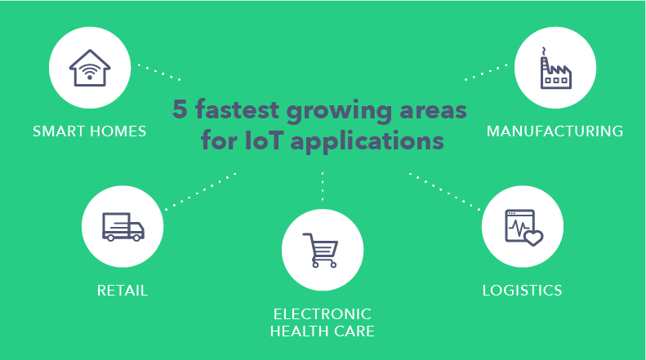

1. **Retail.** The retail sphere opens up ample opportunities to develop apps for the Internet of Things. Such trade process branches as supply chain control (monitoring of the storage conditions of goods at each stage of their delivery) and intelligent shopping (creating a collection of goods based on location, acceptable price range and individual characteristics of the consumer) are the most fertile for the creation of high-end Internet of Things software.
2. **Electronic health care.** Innovative technologies are being introduced to healthcare every year. The IoT concept is actively used in the development of applications for patient status monitoring, diagnostics, monitoring of temperature, moisture and UV radiation in medical products storage, as well as analysis of environmental conditions, etc.
3. **Logistics.** Logistics are one of the most viable areas for the implementation of Internet of Things. Using active and passive RFID tags, equipped with integrated chips, antennas, and GPS trackers, such applications provide an integrated approach to tracking the location of transported goods. In order to transform data collected from sensors, logistics companies hire professionals to develop highly specialized software based on the Internet of Things. Such solutions are compatible with even low-performance mobile devices.
4. **Manufacturing.** The "machine-to-machine" principle was the forerunner of the Internet of Things concept, with a simpler structure (unlike M2M, IoT implies the use of middleware for data processing). This has been an indispensable attribute of industrial software in recent years. Nevertheless, existing M2M solutions can be integrated into the Internet of Things. An example of this is the software for the implementation of production tasks. Such solutions include digital product quality control systems, asset management systems, production equipment management systems, etc.

## Summary

In view of the relevance of the Internet of Things, there are a lot of training resources and tools today that will allow the creation of IoT solutions in a relatively short time. In addition, monies spent on the development of IoT applications in the coming years[will grow rapidly](https://www.statista.com/statistics/485252/iot-endpoint%20-spending-by-category-worldwide/). This indicates the great potential of the Internet of Things ecosystem.

We can argue that IoT development is one of the most promising sectors in the IT business. We, at [applikeysolutions.com](https://applikeysolutions.com/), have already created more than 20 similar projects in the last year, and have all the needed expertise to help materialize each customer’s vision. Numerous areas for the application of the Internet of Things, as well as a wide selection of platforms and programming languages for the creation of appropriate apps, provide our developers with vast resources and skills to make the process fruitful for all parties involved.